
Job Opportunities
2026 General Election

- Help deliver New Zealand’s biggest public event – the 2026 General Election
- We need people to work at voting places and electorate headquarters

The Electoral Commission is recruiting for roles across New Zealand to deliver the 2026 General Election.
Whether you want to work for several weeks or just for a day, there's a variety of options to suit you. All our roles are paid and available on work.elections.nz
You can apply online or you can visit an Electorate Headquarters (HQ) and we’ll help you apply. We also have paper applications, which are available on request.

Headquarters Roles HQ Support Staff (HQS)
There are many roles in our Electorate Headquarters and pay rates range from $28 - $33.80 per hour.
Different HQ Support roles help in each electorate. HQ Support Staff general duties may range from supporting a manager, working as a recruitment assistant, van driver, phone programmer, receptionist, to supplies packing.
Support staff may also count votes and complete tasks after the election. Staff may do different tasks at different times during the election period. Other HQ support staff may take on extra responsibility or specialise in a process or area.

Voting Place Roles
There are a range of roles available in our voting places. Pay rates start from $28 per hour and training is provided.
Voting Place Manager: A Voting Place Manager is responsible for a voting place. This includes managing staff, processes, and materials. The Voting Place Manager works to ensure excellent service is provided to all voters and looks after the security of people and materials. People in the role need to be able to lead a team, use technology, and follow processes.
Voter Assistant: The Voter Assistant works at the front of the voting place greeting voters. This role manages voter queues, directs voters to the right place, answers queries, uses an app to assist voters with enrolment, and ensures that voters follow health and safety measures in place. People in this role will have good customer service skills, be comfortable talking to the public, and can use technology.
Issuing Officer: An Issuing Officer works in a voting place and is responsible for accurately issuing ordinary and/or special votes. Issuing Officers receive training so they can provide a good service to our voters. People in this role will need to be comfortable interacting with voters and able to follow our processes.
Mobile Voting Team: A Mobile Voting Team provides voting services in locations such as hospitals, care homes, New Zealand Defence Force bases, and prisons.


How to apply
You can scan the QR Code (on the right) to take you to our website.
OR
Visit https://work.elections.nz
The steps below take you through the process to apply:

Step 1 – Locate a role you are interested in
You can either scroll through the current job opportunities or use the search function to filter the jobs
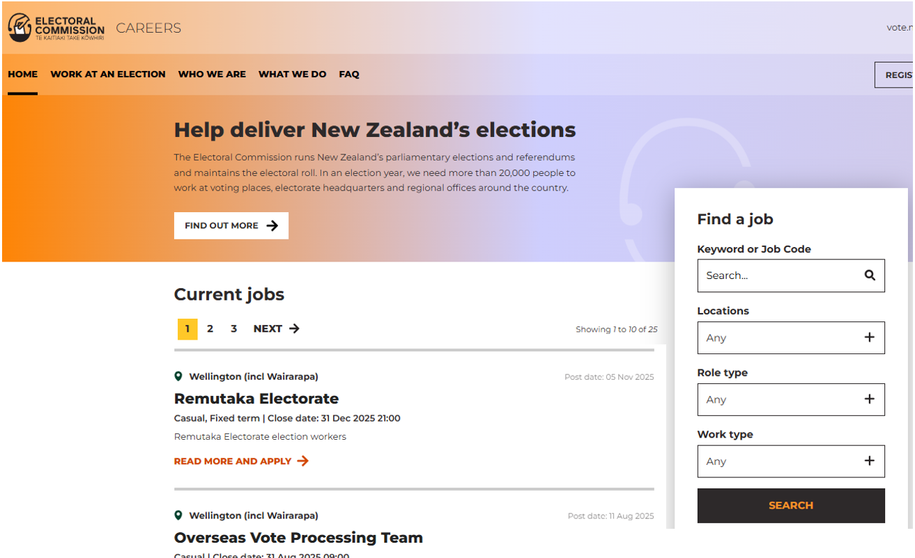
- Select ‘Locations’ 2. Select Work Type
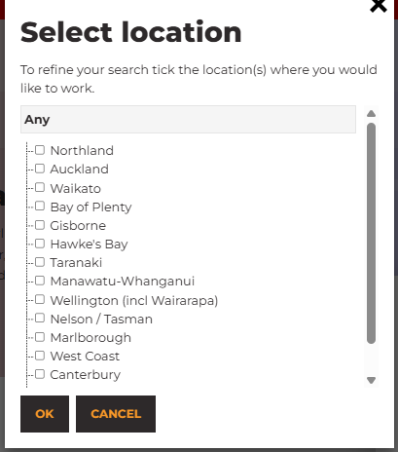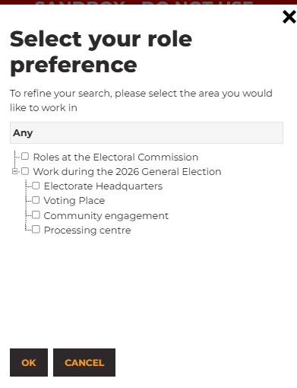
Select the region you are looking for a role Select if you have a preference of where you would like to work
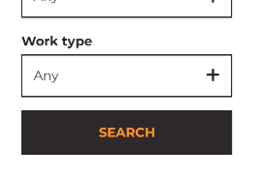
Then click on ‘Search’

Part 2 – Applying for a role
When you find a job you would like to apply for, follow the next steps.
- Click on the job title or ‘Read more and Apply’
- At the bottom of the page (scroll down) you will find a button to apply.
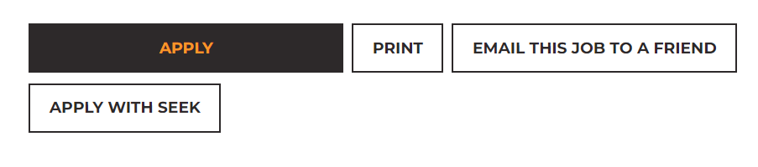
- Select your Google, Microsoft or Slack account or ‘email’ to continue your application.

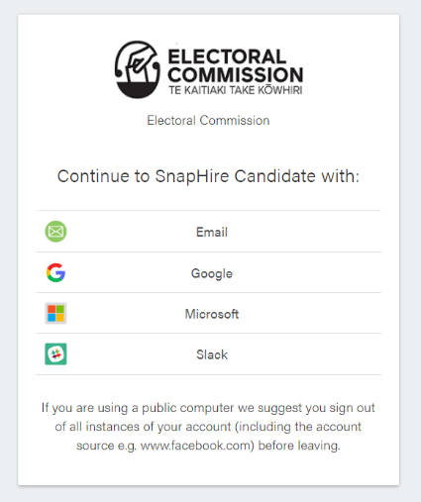

- Then either fill in:

  - ‘I already have an account’ – if you already have a profile set up from the 2023 General Election

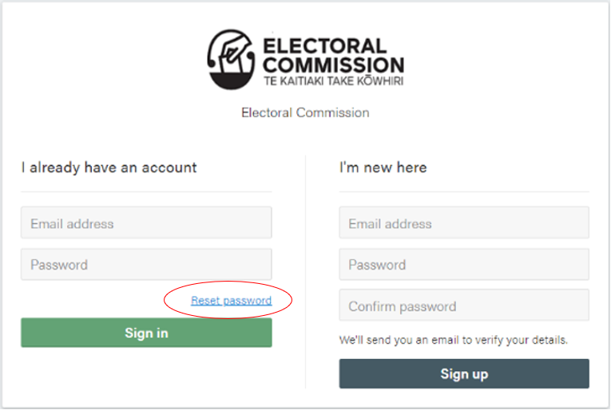
Note: If you have forgotten your password, select ‘Reset password’ to have a link sent to reset your password.

  - OR

‘I’m new here’ - add your email and create a password. Then click ‘sign up’ if you have not previously registered with us.
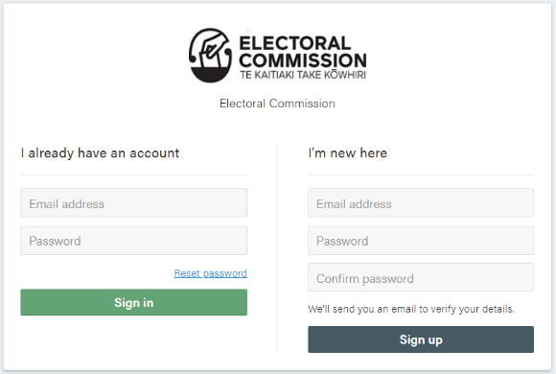

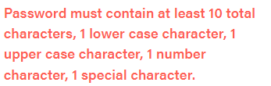

Hint
If you don’t have an email address, you can use a family member’s or friend’s if they are not also applying for a job with us. If you don’t have an email, you can contact us for instructions on how to set up an email address or a paper copy of the application form.

- Next, you will see a message thanking you for signing up. This will show the email you signed up with (where the black rectangle is below). The Electoral Commission will automatically send you an email. Open that email and make sure to click on the link within 60 minutes. Otherwise, you will need to start your application again.

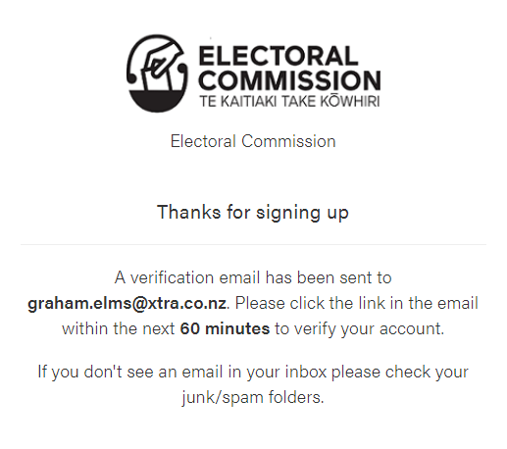

- The email will look like this but with the email address you used to apply:

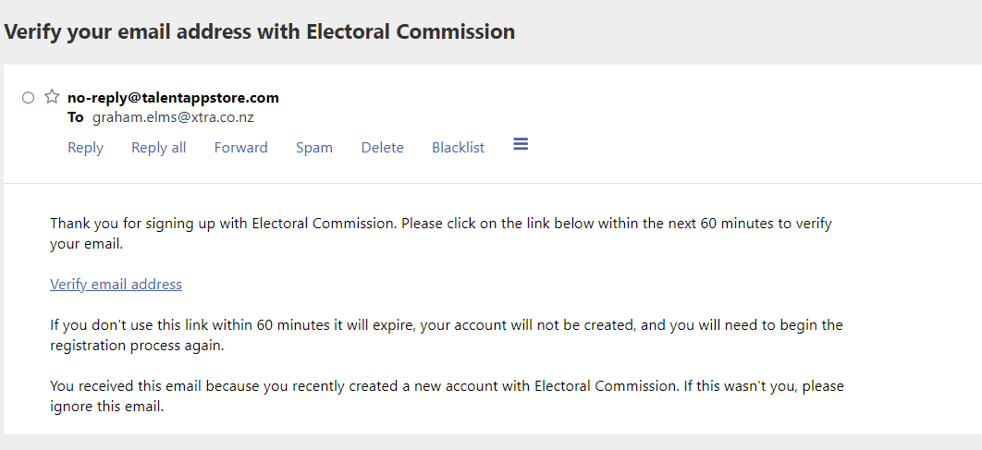

The email will be from no-reply@talentappstore.com and the subject will be ‘Verify your email address with Electoral Commission’

- The link in the email is safe to click on.

- This will take you back to the Electoral Commission website where you will be asked to enter your details (see below example).

* This asterisk means that you must provide that information.
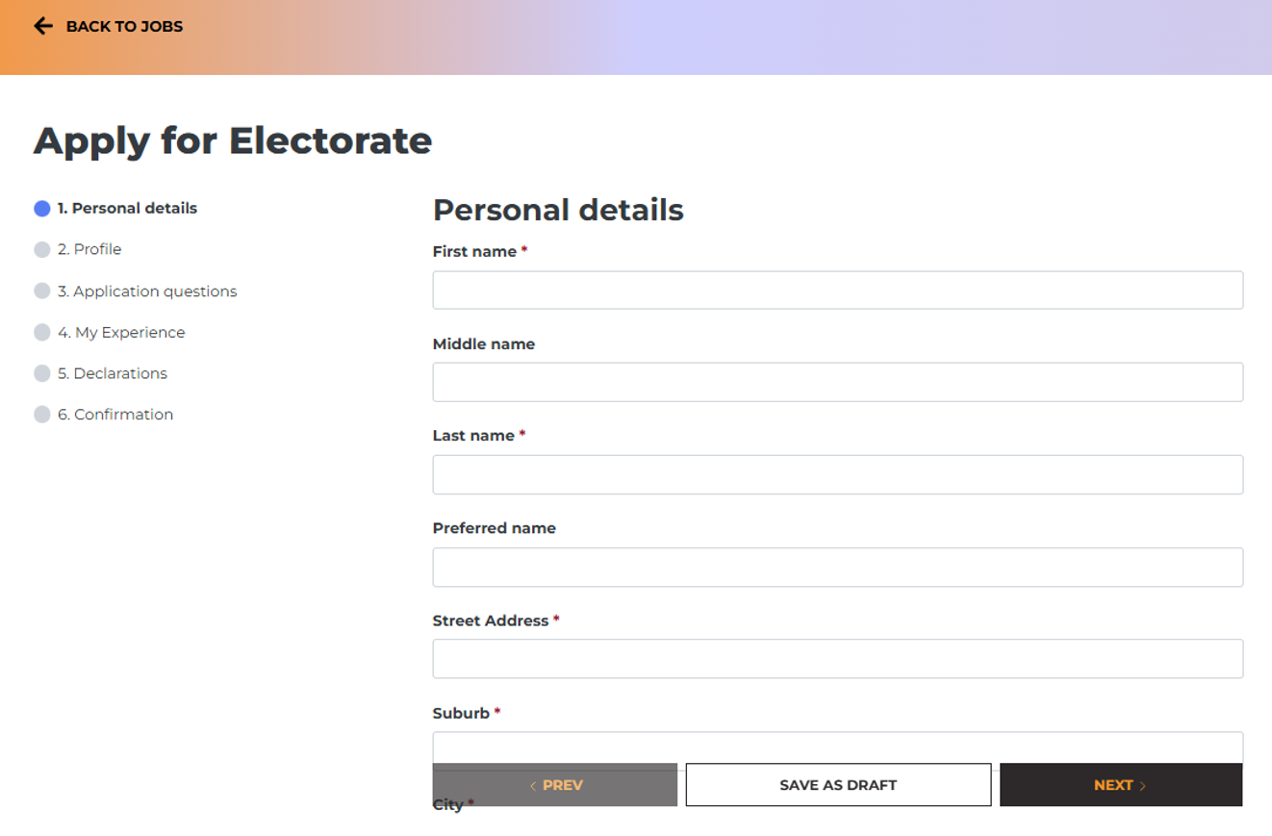
- At the question ‘Where did you hear about us?’ (see below) you can select ‘Referral’ or ‘Community Event’ and then add the event you attended e.g. recruitment evening or a person’s name or job title e.g. Recruitment Manager. See below.
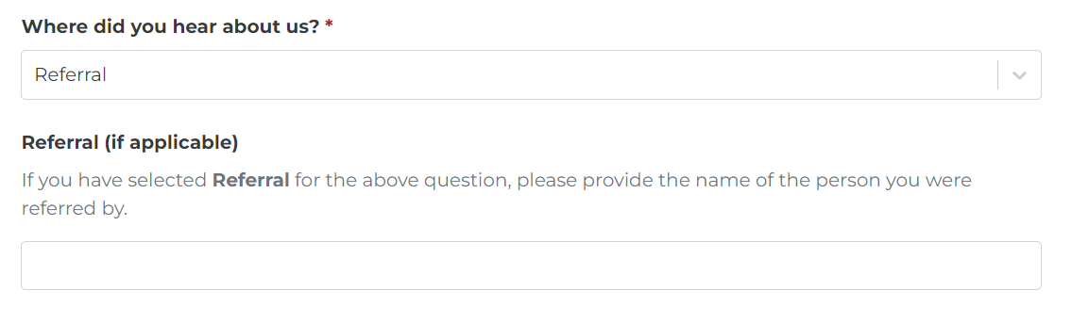
At the end of each section click on ‘Next’ to move onto the next page.
You can click ‘Save as Draft’ if you want to log out and finish your application at some other time.
Hints for Section 2: Profile
- For ‘Work Type’ – select ‘Casual’
- For ‘Role type’ – click on the + beside ‘Work during the 2026 General ELection ’ and tick ‘Voting Place’ or ‘Headquarters’ (you can tick both)
- For ‘Location’ – select your region

- Continue through to the next page, answer the questions, and click ‘Next’ at the end of each page
- Some questions have dropdown boxes that you need to choose an answer from
- You will be asked to tell us about yourself you can either upload your CV or a cover letter or write the details by clicking on ‘Type Document’
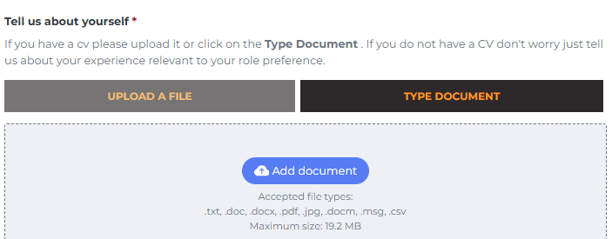
- You will then be asked to confirm all your details.

If you have missed anything there will be a box (like the one below) at the bottom of the page. You will need to go back and answer that question or upload any documents you are missing. You can see which section in the top left corner of the page
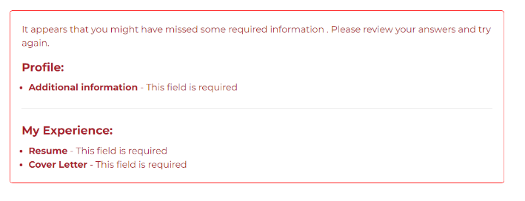
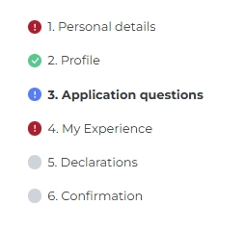


- Then click ‘Submit’.

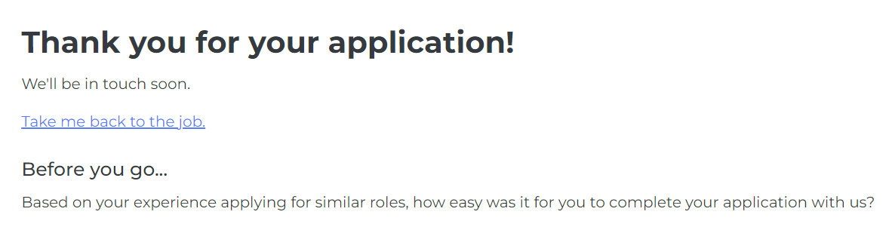
- You will see the following message and a 2-question survey about the application process.

- You can now close the web page. You will receive a confirmation email from Careers at Electoral Commission<noreply@elections.nz>

- We will process your application and contact you via email. If you need any help, please let us know.

We look forward to receiving your application!

