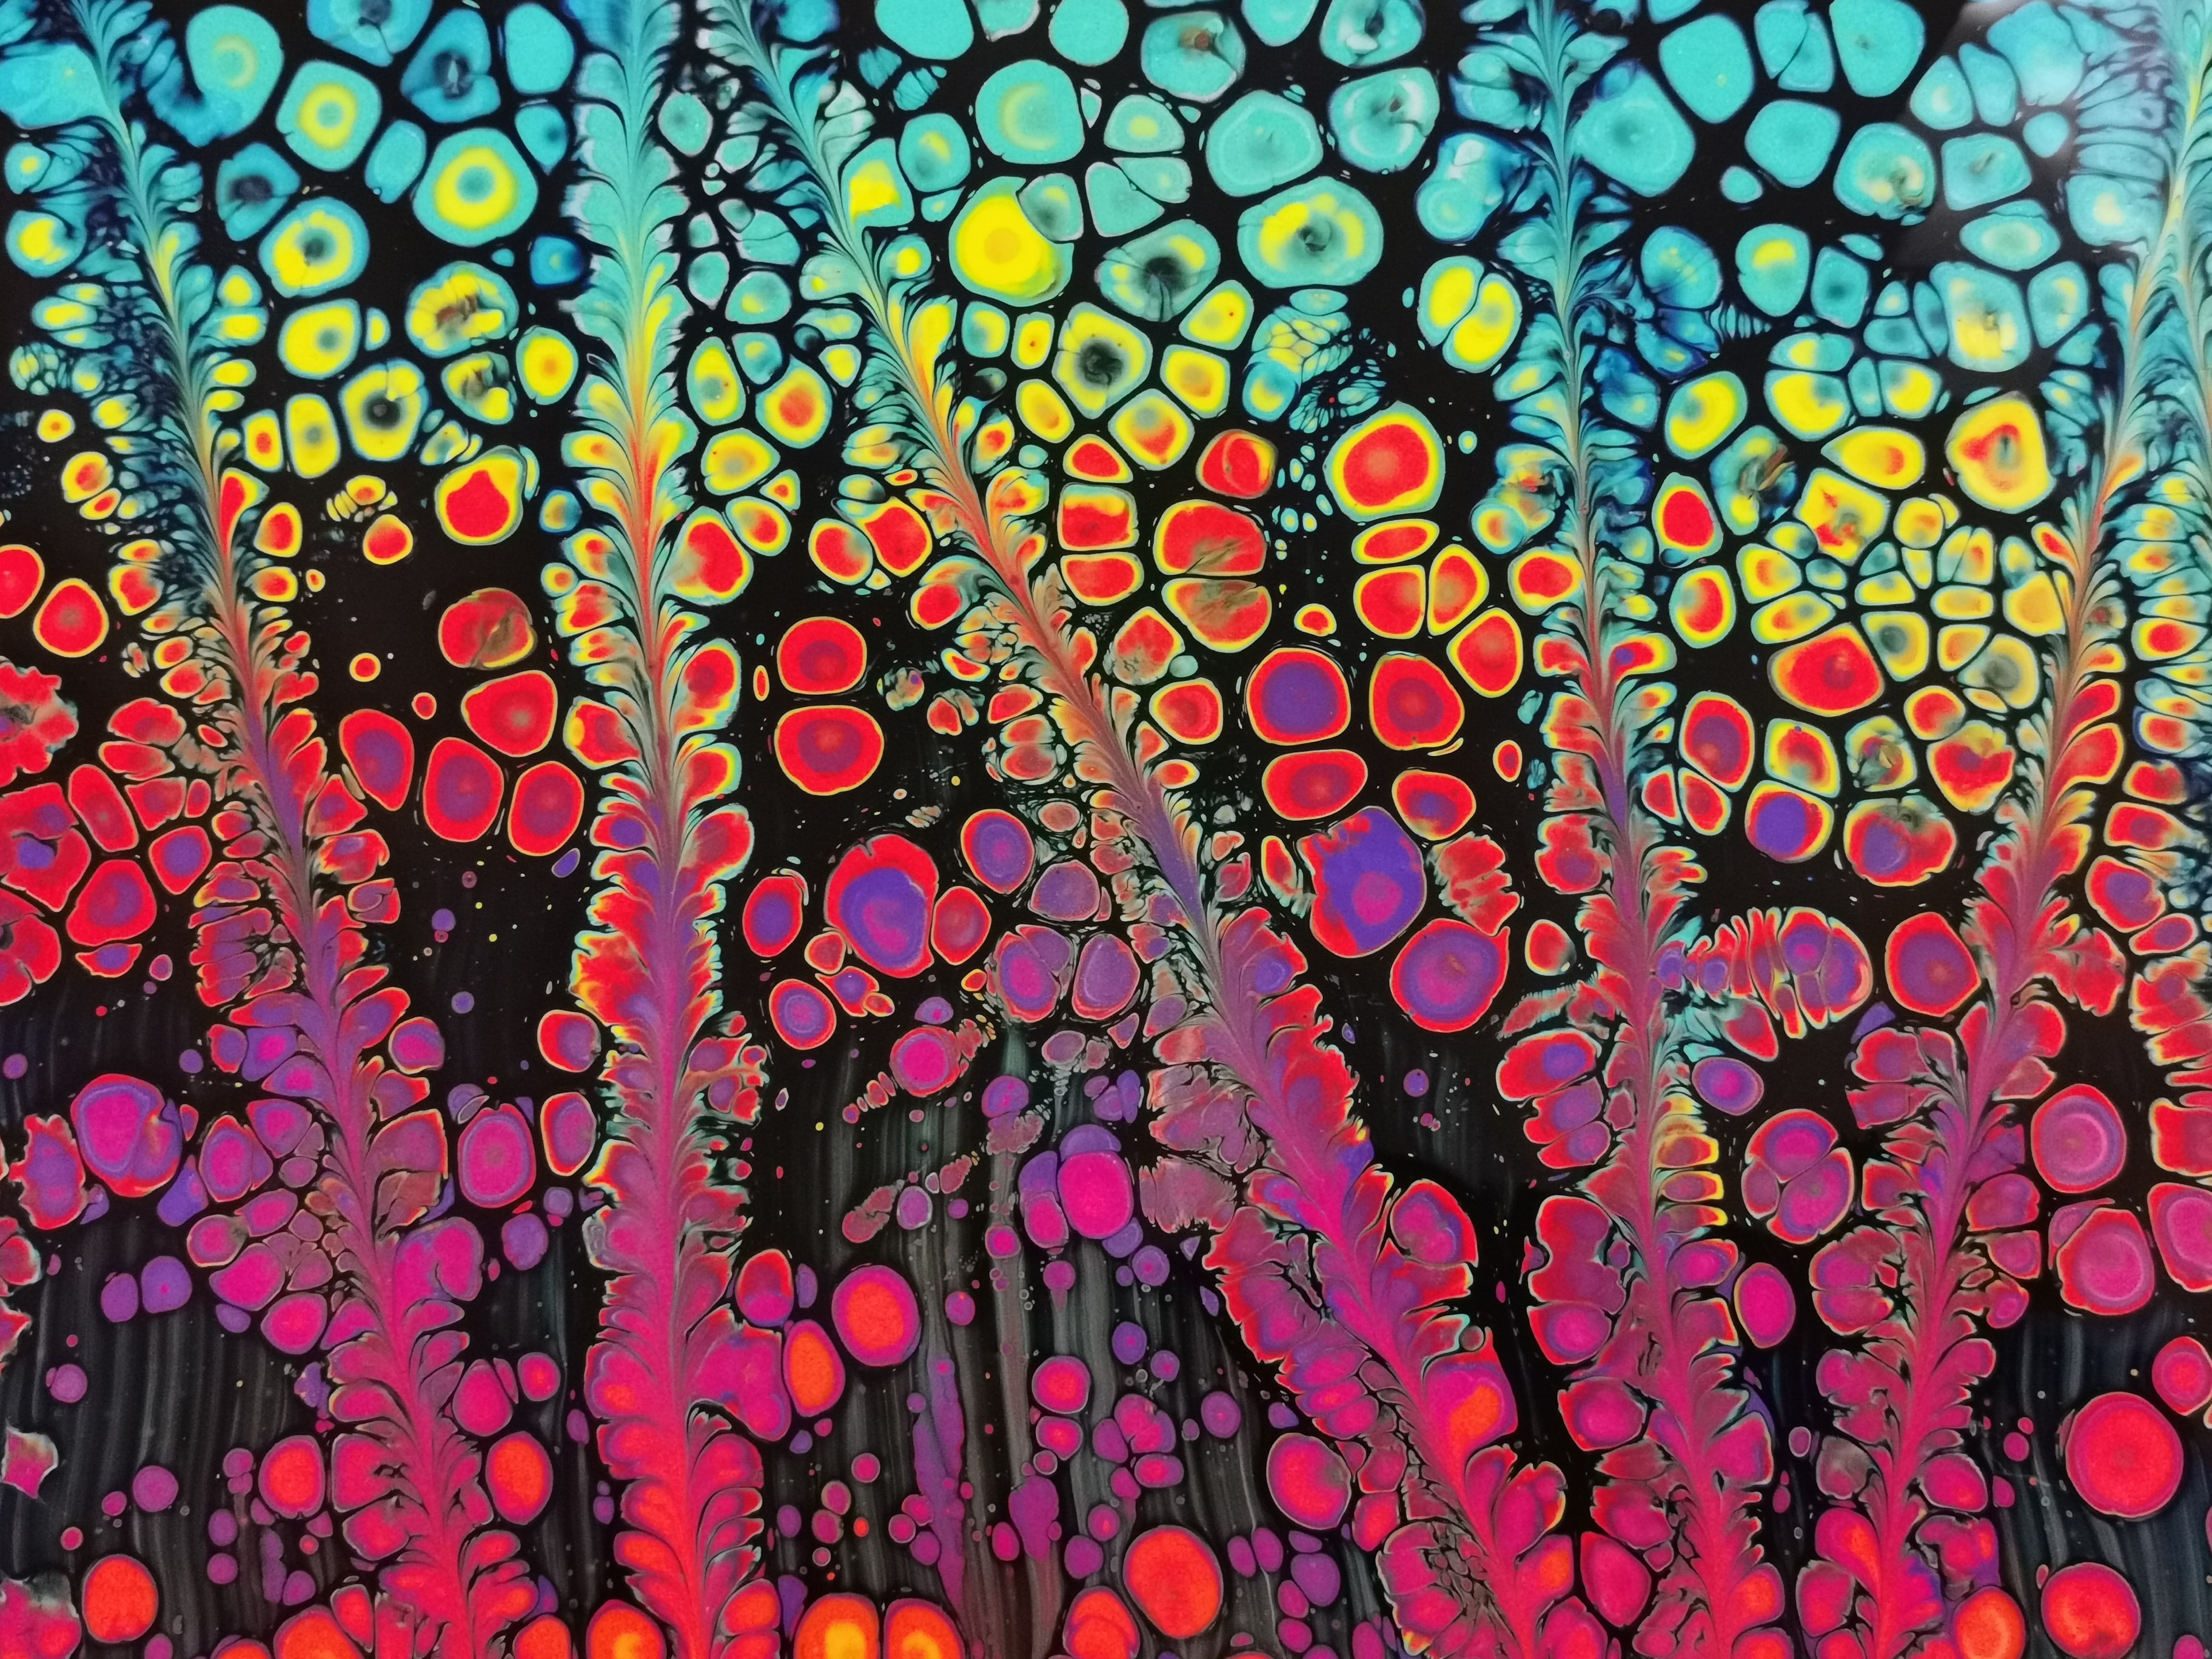
Papakura Library

RRR Art Competition
  - Reuse Recycle Repurpose Art Competition & Exhibition
The theme is ‘My Environment, My Identity’

This Matariki, be the kaitiaki of our environment and use your imagination to ‘Reuse, Recycle or Repurpose and the theme of your work is ‘My Environment, My Identity’. Pick up an Entry Form from Papakura Library or Sustainable Papakura.

Awesome prizes to be awarded for
- Best Group Category – Whanau (Open age)
- Best Individual Category – Tamariki (Under 16 years)
2. Best Individual Category - Rangatahi (16 years and up)
3. Most Popular by Public Voting

Artworks can be of any genre but must use construction and materials that are 100% natural/biodegradable or re-purposed. Your artwork will be judged for the creative expressions of RRR (Reuse, Recycle or Repurpose), Creative use of materials, Sustainable Construction and Sculptural & Artistic Elements.

Sustainable Papakura will be hosting a few workshops that can assist in your artwork creation. Please check out our Matariki Calendar for details of these workshops.

Important Information
Competition opens Friday, 02 July. Please register and pick up an Entry Form.
Entry Form and Artwork Drop-off Deadline Saturday, 24 July, 4pm. All drop-offs to Papakura Sir Edmund Hillary Library. Please submit artwork together with entry form.
Exhibition and public voting: 26 July – 30 July.
Winners announced: 31 July 2021

For further information contact Papakura.Library@aucklandcouncil.govt.nz or Phone 09 377 0209
Find out more: visit
www.facebook.com/papakuralibrary/events/

Papakura Library

RRR Art Competition
  - ENTRY FORM

ART CATEGORIES: PLEASE TICK ONE BOX ONLY
- Group Category – Whanau (Open Age)
- Individual Category – Tamariki (Under 16 years)
- Individual Category – Rangatahi (16 years and Up)

Name:
Age:
Organisation:
Contact email:
Contact Phone number:
Address:

Title of Artwork:
Artist Statement (Tell us about the artwork/What inspires your artwork):

Find out more: visit  www.facebook.com/papakuralibrary/events/ | Office use only  REF#
**Note on artwork dimensions: All artwork must be prepared to be displayed on a table or standing on the floor and must be able to be lifted by maximum 2 people. Your artwork might not be accepted if it does not comply with these requirements.

