BMX Racing

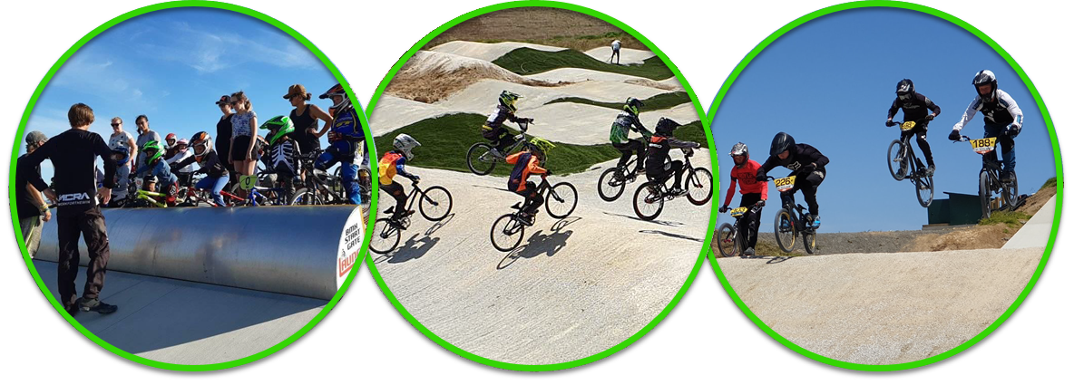
Have a Go Day

New riders welcome

Come down to Manukau Taniwha BMX track in Colin Dale Park and give BMX racing a go. It's such a fun sport that the whole family can get involved in
Sunday 29 March 2020
Coaches will be available on the day
Registration for new riders from 11.45am
Start time 12.00pm to 2.00pm
Bikes, full-face helmets and gloves available on the day
Riders must wear long pants, long sleeves and shoes
Please check Facebook @taniwhabmx for cancellations
For more info: Contact us on Facebook or email info@taniwhabmx.nz
Colin Dale Park – 87 Prices Road, Wiri

